**1. Executive Summary.**

**Purpose:**

1. To inform the Board of Directors of the progress against national requirements for staffing data reporting as outlined in The National Quality Boards (NQB) and NICE guidelines on safe staffing levels.
2. To bring to the attention of the Board of Directors any workforce issues / areas of concern.p
3. To seek Board of Directors approval of the hospitals nursing establishment.

**The report makes the following assertions:**

1. The Board should ensure there is sufficient and sustainable staffing capacity and capability to provide safe and effective care to patients at all times.
2. Safe staffing is a fundamental part of good quality care and the CQC will, therefore, always include a focus on staffing in the inspection frameworks for Spencer Private Hospitals (SPH) as a healthcare provider.
3. It is critical that the Board reviews workforce metrics, indicators of quality and outcomes and measures of productivity on a quarterly basis.
4. The Board should use this report to support their judgements and decisions about safe staffing at SPH.

**2. Safe Staffing Background**

This review observes the recommendations set out by the National Quality Board (NQB) guidance published in July 2016 *“*[*Supporting NHS providers to deliver the right staff, with the right skills, in the right place at the right time: Safe, sustainable and productive staffing*](https://www.england.nhs.uk/wp-content/uploads/2013/04/nqb-guidance.pdf)*” and the NQB’s subsequent guidance*  *‘Safe sustainable and productive staffing: An improvement resource for adult inpatient wards in acute hospitals’* inDecember 2016

This safe staffing improvement resource provides a set of expectations for nursing care staffing to help SPH make decisions that will support the delivery of high-quality care for patients within the available staffing resource. The resource set out the key principles that the SPH Senior Management Team use to measure and improve their use of staffing resources to

ensure a safe, sustainable and productive service, including the care hours per patient day (CHPPD) metric.

The resource identifies the three NQB expectations that forms a ‘triangulated’ approach (‘Right Staff, Right Skills, Right Place and Time’) to staffing decisions; and offers guidance to SPH on using other measures of quality alongside CHPPD, to understand how staff capacity may affect the quality of care provided. Utilizing these resources assists SPH to ensure it has the right culture, leadership and skills in place for safe, sustainable and productive staffing whilst maintaining proactive, robust and consistent approaches to measurement and continuous improvement to support safe, effective, caring, responsive and well-led care.

Setting appropriate planned levels of staffing is, therefore, fundamental to ensure SPH reduces any potential risk of patient’s not experiencing high quality nursing care.

The NQB resource shown below has been used by SPH alongside our CHPPD to demonstrate and understand the impact of our staffing decisions on the quality of care that patients are receiving in our ward area.



Because adult inpatient environments, whether they are in the NHS or Independent Sectors, vary so much, no standard definition of them exists. The NQB and its members have therefore adopted NICE’s definition for consistency. They recognise that variations exist, and that leaders must take into account factors such as ward layout, geography and estate when

calculating staffing needs. They recognise the need to consider the wider multidisciplinary team when looking at the size and composition of staff for any setting, but as there is little workforce modelling or planning evidence on how this has been successfully achieved, they have concentrated on nursing and signpost evidence we found to inform multi-professional workforce planning.

**3. The Review Process.**

The Carter review identified 9 key practices that are the elements to a successful hospital. This is the concept of the Model Hospital. This review supported the NHSI’s guidance which aims to support healthcare providers to give patients safe, high quality compassionate care that is financially sustainable.

During 2019-20 a clinical nursing review was undertaken with the Senior Management Team (SMT) enabling sufficient challenge and scrutiny of the workforce. This enabled a clear view of the support required in the coming year. The review included an overview of the budgeted establishment and the vacancy, sickness, and training data relating to the nursing workforce.

During 2019-20 progress has been seen with staff development plans for HCA’s who have expressed an interest to develop their skills further and commence the Associate Nursing Training Program. This will be taken forward into 20-21.

Quality measures were also reviewed for each area including Datix Incident reporting, Harm Free Care statistics, complaints, patient experience surveys, and Friends and Family feedback. The organisations quality assurance system was additionally reviewed along with any staff and patient feedback relating to staffing and patient safety.

**4. Current Position.**

Spencer Private Hospitals (SPH) have a duty of care to ensure that all patients are cared for by appropriately qualified and experienced staff within a safe environment. To support this objective, the organisation continues to utilize its Nursing Dependency Analysis Tool to ensure safe staffing levels are maintained which is demonstrated by the hospital’s quality metrics. This practice is reflected within the Care Quality Commissions (CQC’s) six standards applicable to all healthcare providers, and the National Quality Boards (NQB’s) Nursing Workforce Program.

**4.1. Spencer Staffing Data.**

In 2019 - 20 SPH continued to publish Safe Staffing data internally on patient information boards in ward areas. The published data demonstrates levels of contracted staff, self-employed staff, agency usage and skill mix, and the number of Care Hours Per Patient Day (CHPPD). The information is also published on the organisation’s web site.

|  |  |  |
| --- | --- | --- |
|  | **CHPPD** | **CHPPD Base** |
| **Mar 20** | **5.90** | **5.00** |
| **Feb 20** | **5.20** | **5.00** |
| **Jan 20** | **5.60** | **5.00** |
| **Dec 19** | **5.80** | **5.00** |
| **Nov 19** | **5.60** | **5.00** |
| **Oct 19** | **5.30** | **5.00** |
| **Sep 19** | **5.90** | **5.00** |
| **Aug 19** | **6.10** | **5.00** |
| **Jul 19** | **5.80** | **5.00** |
| **Jun 19** | **5.20** | **5.00** |
| **May 19** | **5.80** | **5.00** |
| **Apr 19** | **5.50** | **5.00** |

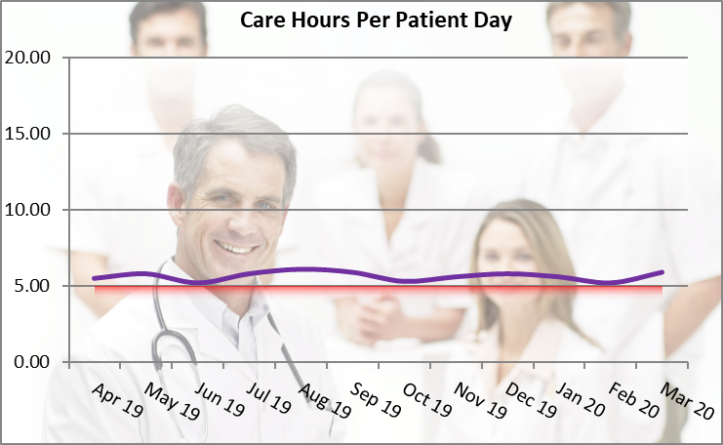

**4.2.      Current Contracted Ward Nursing Establishment.**

Qualified Nursing Establishment        12.45    WTE

HCA Establishment                             3.0    WTE

SPH has a Matron at Margate who is overseen by a Head of Clinical Services who works across the organisation. Their roles are not generally included in the nurse staffing levels as they provide leadership, management and support in addition to the staff who deliver patient care. The importance of these roles being supernumerary to the agreed staffing levels was recommended by NICE and supported further by the RCN 2010 and the Francis Report when recognising the importance of *‘Time to Lead’* which can be defined as any duty that contributes to the delivery of safety, effectiveness and patient experience.

The organisation also has Physiotherapists who are not included in the nursing staff numbers but are part of the organisations commitment to providing safe and effective patient centred care.

The current establishment supported by the self-employed staff has enabled the organisation to achieve the annual staffing objective of providing every patient over 5 hours of the nurse’s daily hours spent on actual patient care per day.

In addition to the above-mentioned data each month ‘*Harm Free Care’* statistics are published along with *‘Never Event’* data.

Monthly Health and Safety and Complaints reports are also provided to all staff and the Board of Directors; lessons learnt are shared with all concerned.

**5. Summary.**

In line with the NQBs resource and other available resources SPH reviewed its Nursing Dependency Tool in 2019-20 to ensure it met with the organisations clinical ward requirements. Our clinical workforce has also been reviewed regularly during the year to improve efficiencies and ensure agency usage in the ward area are only for emergency / unforeseen staff shortages. Recruitment of clinical ward staff has been difficult over the past year; however, vacancies are slowly being filled.

Staff clinical training programs have also been reviewed and the Relias training system is working very well to ensure all our staff maintain the appropriate skills to continue to deliver safe, effective, caring, responsive and well led care in line with CQC and NQB expectations.

**No Red Flag events were reported relating to safe staffing levels during 2019-20.**

SPH Patient Satisfaction results, clinical outcomes, low infection rates and clinical incident statistics, PLACE, ISO and CQC audit and inspection results supports the organisations view

that the SPH Margate has a clear vision in relation to safe staffing and is maintaining and continuing to achieve company objectives within the organisations strategic 3-year plan

(2019 - 22).

**6. Conclusion and Recommendation.**

SPH will continue to review staffing resources and staff skills to ensure we provide safe, sustainable and productive staffing.

The Board of Directors are asked to receive this paper for information and assurance of the Safe Staffing System in operation.

**Lynn Orrin**

**Hospital Director.**

**16th April 2020**